2010 Summer Institute Evaluation
All Responses

(46 responses/122 attendees – 38% response rate)

Question 1: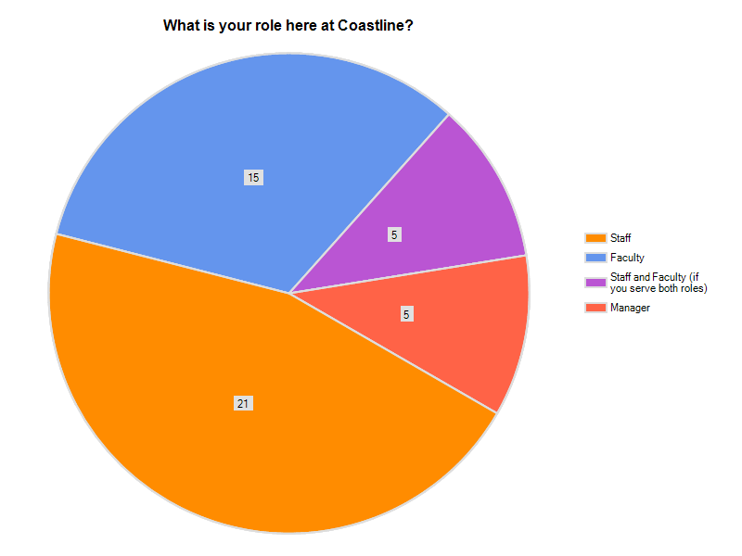

Question 2:
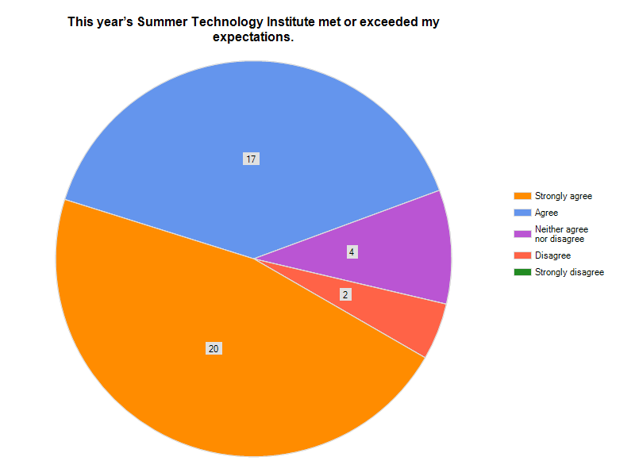
Comments:
1. | 1st year attendee. Really enjoyed the introductions and instruction I received.
2. | it was especially user -friendly and relevant to the instruction of my classes!
3. | I thought this years Summer Technology Instittute was the best since we began.
4. | knowledge of program was helpful, showing short cuts and new ways of doing Words, etc...
5. | Would like some items directed toward staff and not geared solely to faculty.
6. | There were so many sessions and not enough time to attend everything that I was interested in. This is a good thing.
7. | Very impressed.......
8. | well organized. Amazing website!
9. | Amazing amount of information was presented in a very logical and professional manner.
10. | The session on vidoe editing was fantastic. I didn't even know Movie Maker was an application on my computer.
11. | Poorly organized event. Support staff was very helpful but this year was not very good as a full event.
12. | I feel the sessions were all current, inviting, and interesting.

Question 3:
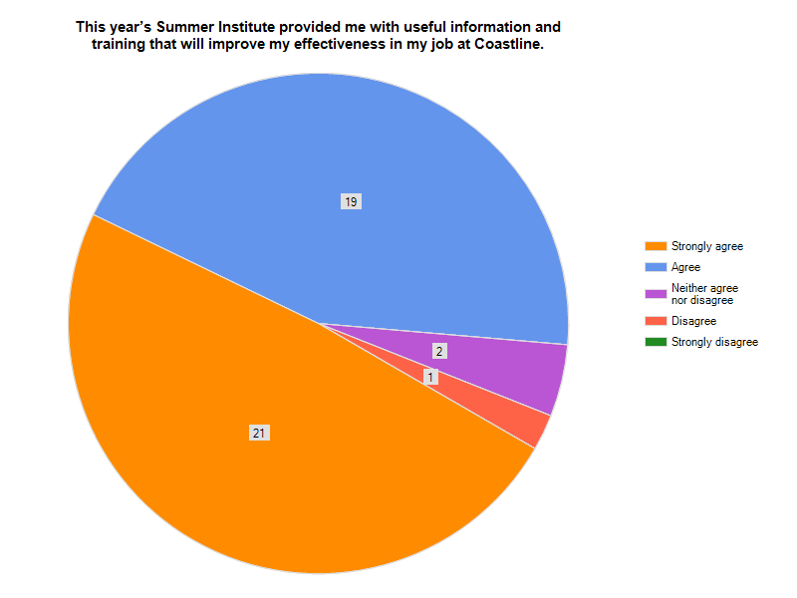
Comments:
1. | As Faculty, I thought the cccconfer.com was great, and it will be very useful.
2. | Including access to EduStream
3. | The workshops I attended were, well presented and very informative.
4. | Love the new ideas, could've used more specific quidance/suggestions for implementation in areas. "how to implement this as a manager...ideas...how to implement this as a faculty member...ideas..." etc.
5. | I teach DL and the information I took away will certainly help me improve my classes.
6. | Education security was only on one day, why not on Friday? The joining of three sessions during the same time was not very good. Needs improvement.
7. | I'll be able to get going on improving my courses as well as working on my sabbatical project that involves Second Life.

Question 4:
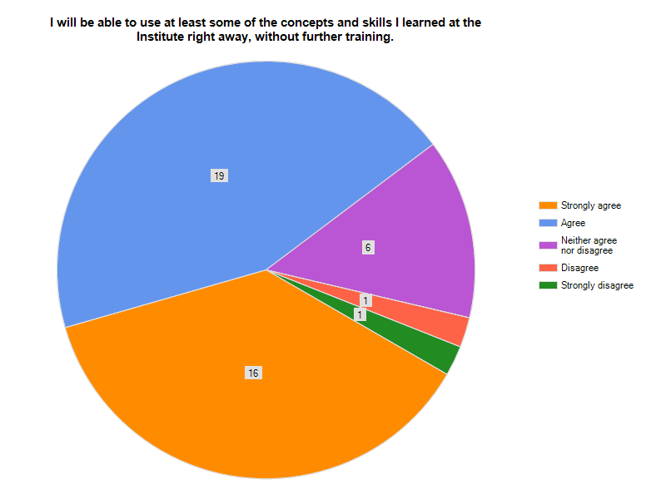
Comments:
1. | The resources available online for the sessions is very helpful.
2. | The presentations were great. I'll personally have to use more of the training elements to get good at them.

Question 5:
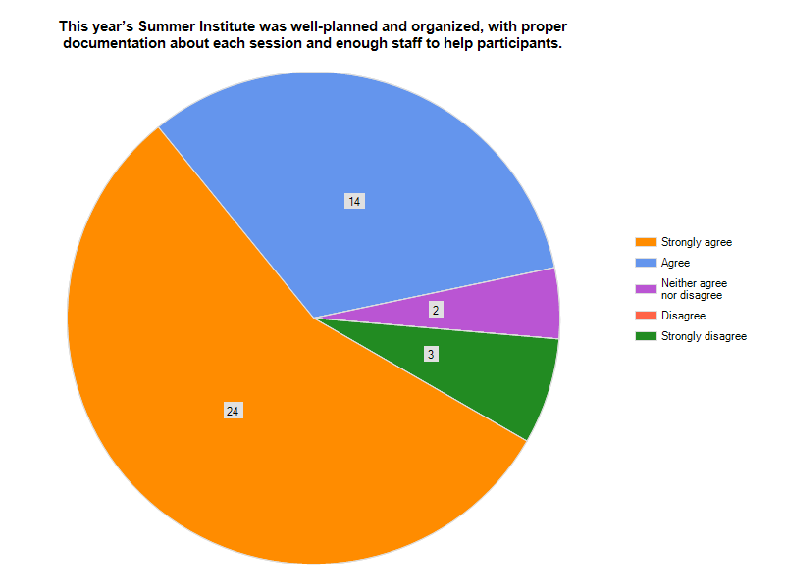
Comments:
1. | Yes, and Ted Boehler set the pace on the first morning when he said we could move from session to session or, especially important, stay in a session to gain the hands-on experience being presented. That comment really eased my comfort level to seek out those sessions and aspects of sessions most relevant to my on-line learning. Thanks!!!
2. | Of the two sessions I attended, the one that was put on by Kristen Le and Isaiah was excellent. I attended the Adobe workshop on Thursday and they weren't well-prepared.
3. | Liked layout - registration and refreshment area out of the way-not blicking the hall.
4. | Schedules were not easy to follow.
5. | Everyone is extremely helpful.
6. | My favorite session was Camtasia with Sylvia Amito'elau! She inspired me to record a video for new Coastline students. (^_^)
7. | In my opinion, very well planned.
8. | The class room changes were a little confusing.
9. | See my points above.

Question 6:
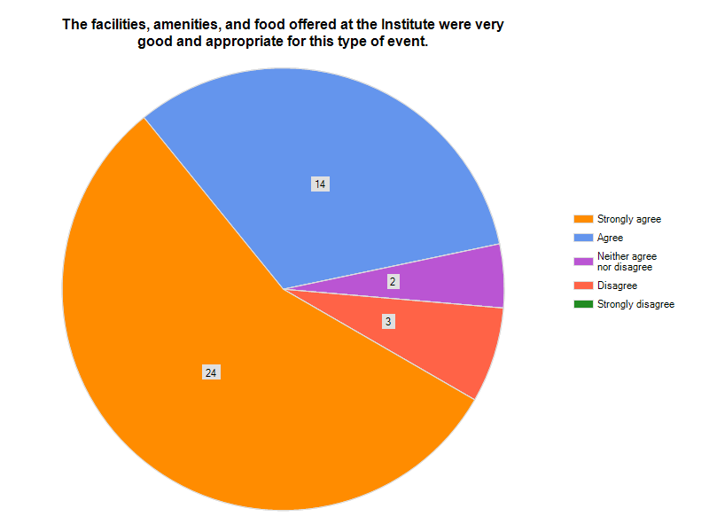
Comments:
1. | Delisious Quiznos sandwiches the first day and I always love pizza (the 2nd day)!
2. | I liked it better when lunch was in room 315
3. | Marie Vaughan did a fabulous job! She was very attentive to detail.
4. | Great job!
5. | Thanks, great foods.
6. | Cant wait for next year!
7. | Great job. Thanks to all who worked so hard to make this event rewarding.
8. | The facilities are so clean, the food excellent, and the staff extremely helpful.

Question 7: Most Useful Sessions
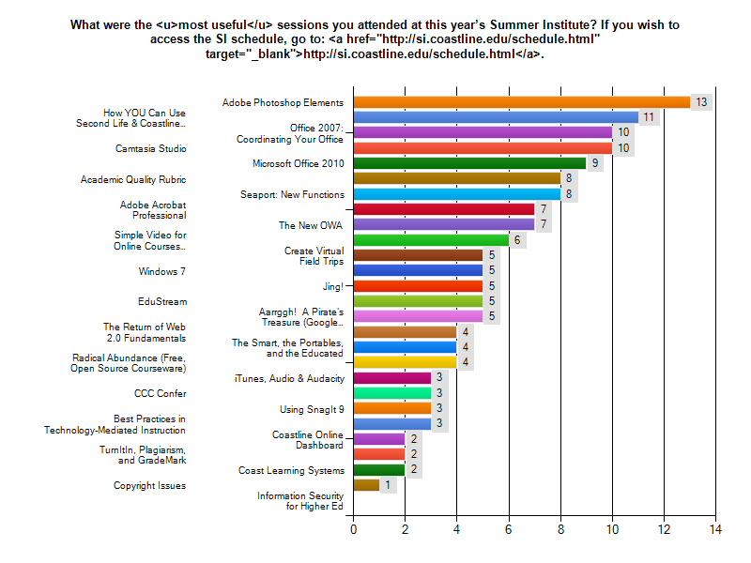
How will these sessions help you improve your effectiveness on the job?:
1. | Video usage, new programs stay on top, better communication with students.
2. | I know how to do more on-line operations. i plan to contact Sylvia to lean Jing and Snagit.
3. | I learned so much at the Office 2007 session that I could apply immediately to my current position. It was the perfect pace and covered pertinent information. They were well-prepared.
4. | Use of EduStream to upload videos and pictures; use of Microsoft Office 2010-will buy it from CCCC Foundation; just loved how we can use our tablet PCs as smart boards AND great demonstration on how to use the smartboard!
5. | These were the ones I attended and enjoyed each one of them and took away knowlege and reminders.
6. | The Office 2007 session will help me be more organized and efficient with my work. Camtasia will give me the opportunity to demonstrate any how-to's to those who need help.
7. | I learned new features about Second Life and hope that I can apply them this coming semester.  I highly appreciate the Seaport New Functions which enable faculty to effectively interact with students in a timely manner.  The CCC Confer is excellent. I am learning to set up this method of communication in my class.
8. | Improve the quality of my courses. Provide more graphics and video for my courses.
9. | The knowledge gained will improve current practices with students.
10. | I gained more skills in using Excel and Word.
11. | Learning these new skills saves time and money by not having to find someone to do these things for me.
12. | We plan to do tours of our websites using Camtasia and/or Jing to promote our services.
13. | Coordinating your Office: Able to start using Publisher right away. Huge amount of infor presented. Loved the hands-on learning.  EduStream: Plan on recommending this site to instructors for adding meaningful content to their course websites.  Coast Learning Systems: Should be required for all faculty/staff to see this presentation. Who knew all that is done in this department.
14. | I didn't relize that there are some many sources of free infromation available. This handout is great.
15. | Provided me a fee tips to apply toy job and for the OWA, I'm looking forward to the new version.
16. | I was not aware of some of the web 2.0 resources available that I can now use for research for my classes.
17. | The Photoshop session will help me use the software handed out, for such things as resizing photos. The Edustream session will help me help faculty use this great resource.
18. | I learned new functions in Excel and more efficient ways to organize information.
19. | The presenters will well prepared. I just couldn't have asked for a more professional event if I had paid thousands of dollars.  No time was wasted.
20. | I am amazed by the development of many website services and tools we can use. Thanks to Kristen, Isaiah, Peter, and other presenters.

Question 8: Please offer any feedback that you feel might make these sessions even more effective in the future.
1. | Keep up the great work!!!
2. | Some sessions (Camstasia and Second Life) need to be continued until the next day. In other words those who attended the first day should have a more advanced hands-on session for two hours the next day.
3. | Presenters should try out their programs/files prior to the class to ensure that they are operational. The computers should already be set up to begin work to make the best use of time.
4. | Really appreciate the opportunity to attend Coastline's Summer Institute. A lot of work and preparation goes into this training and it shows! Want to express appreciation to Eric Wilson for scheduling an additional MS Office 2010 workshop late Friday afternoon on July 9. Enjoyed use of tablet PC and to Shanon Gonzalez on how to effectively and practically use the tablet PC - no more filing!
5. | I wish to know more about how to insert video clip in Second Life.
6. | More time for the hands-on computer sessions. Rather than just a brief introduction to the program, I'd like to have more time to really learn it. Maybe a half day session?
7. | I thought they were all great.
8. | Loved every minute of my time at Summer Institute. Wish all the classes could be duplicated so I wouldn't have to do so much picking and choosing. Great job gang!!
9. | It might be helpful to do a survey prior to the series to see what programs staff are looking for. I think the programs selected were very helpful this year though.
10. | Office 2007: Coordinating Your Office could have been broken up into two sessions, there was so much info to cover. All the sessions should have been 2 hours long. One of the 1 hour session presentors thought he had 2 hours. There were not enough 1 hour sessions to make chosing one appealing.
11. | SI was well done again this year.
12. | The Video Editing session presenters could have been more organized/prepared. Some of the files were not available for us to create our own video introduction. Perhaps the presenters could have tested everything beforehand. But, it was still a very good session.
13. | All the sessions I attended were very well presented.
14. | As a presenter, I would make sure I had a nice PowerPoint presentation. I would still like to make this and make it available to the attendees. Marg Taylor

Question 9: Least Useful Sessions
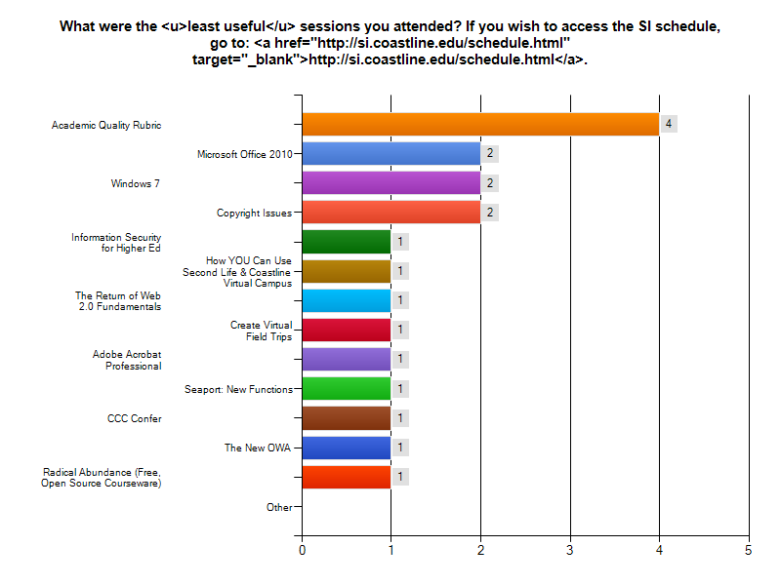
Please offer any feedback you feel would make these sessions more effective:
1. | I didn't.
2. | I did not think there were any weaknesses--only wish there was more time to go to all the sessions! I love the upbeat, fun, and professional instructional style of all the presenters!! Thanks.
3. | All of the sessions that I attended were useful.
4. | please see previous comments.
5. | I wish I could have attended more of these training workshops.
6. | I likes them all
7. | Since I'm not an instructor, this didn't apply to my current job, but was interesting.
8. | All the sessions I attended were useful.
9. | There wasn't that much new info to be presented. Didn't learn all that much. Make sure the presentor has chosen a few "wow" points to share with the attendees.
10. | Just too much material, needs more focus.
11. | Web 2.0? That is not web 2.0. I believe the presentation was about social media and 2.0 is a service for social media. Points to the presenters in trying. More knowledge is needed.
12. | appreciated all the sessions I attended.
13. | This session was not bad by any means. But, the presenter could have offered more specific details and "how to" information. Then again, maybe that was too hard to do using test/trial software. As a basic intro, this session was still pretty good.
14. | None.

Question 10: Want Further Training
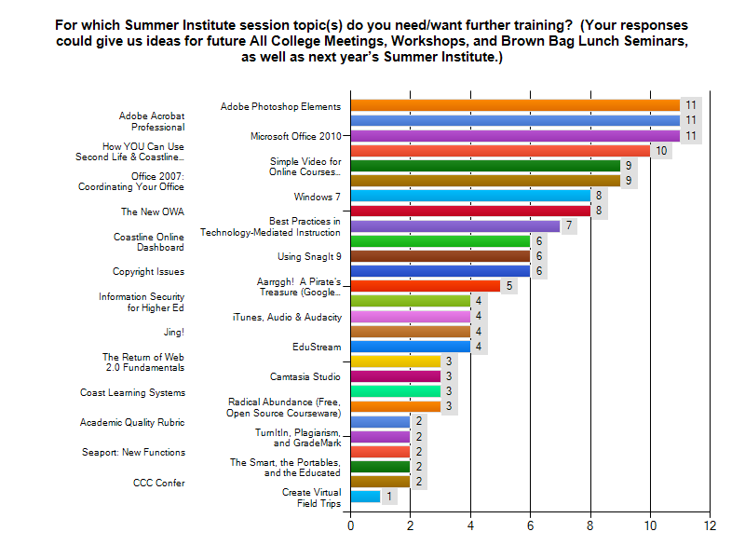
Comments:
1. | I want more training--thanks,
2. | Turnitin.com lesson rubrics for us who use turnitin.com. I'd recommend, if available, Kristen Nichols to be the presenter.
3. | None
4. | For video editing, I still don't know how to do a simple "insert" edit, at least, I think it should be simple. It would be nice for the presenters to create a reference aid with step-by-step instructions to do the most typical things in Movie Maker. They can use Snag It!

Question 11: What new topics would you like to see covered at next year’s Summer Institute?
1. | I don't know at this point.
2. | Follow-up on Microsoft Office 2010-most likely we will have this software installed.  Updates on Future of Technology and Use of Technology at Coastline. More info on IPADS. Best places to buy software and computer equipment.
3. | Surveymonkey, Dashboard
4. | can't think of any right now
5. | How could I monitor students attendance in an online class?
6. | eportfolio
7. | PowerPoint
8. | ?
9. | Digtial editing (document mark-up using Acrobat), Preparing your materials for Graphics/Publications (how to submit your program info for design), Using Facebook and Twitter to connect with Students, Using the SHAREpoint server (if we HAVE that by then)
10. | MS Access
11. | Skyppe from inception to implementation for classroom use.
12. | Security session is very important and there shoul have been more than just one.
13. | ??
14. | Can't think of anything new right now.
15. | I won't know until next year, but I know that Second Life will be larger. I'd like to show my sabbatical project.
16. | iTunes University

Question 12: In what other ways could we have made this year’s Summer Institute more useful and enjoyable for you?
1. | I felt this year's Institute was one of the better ones.
2. | Keep doing what you are doing. SI continues to be most useful and enjoyable - especially seeing faculty, etc.
3. | everying was well put together.
4. | Can't think of it right now.
5. | end both days at 3 pm then come together for 15 minutes
6. | ?
7. | very accomodating...loved it.
8. | Hated the pre-packaged fruit provided at breakfast, couldn't even eat it and I love fruit!
9. | I personally think that this is a fantastic event. My thanks to all the staff who worked so hard.
10. | Better planning.
11. | ??
12. | How can you say you want more when you've been given a free shopping trip to Tiffany's. This is how I feel about this year's Summer Institute.
13. | Better organized. The first day had thress really good sessions, the security session I wanted to attend but could not and thought it was going to be repeated on Friday. Not very smart by doing this.

